Name: C.Yuvaraju Reg no:192424354

DSA0111 CO3-AT1 Analytical Problem Solving

Question 1: Banking Account Management System
A banking application needs to create and manage customer account objects. The system should support different ways of initializing an account depending on the information available.
Design a C++ program using a class Account with the following constructors:
Default constructor – initializes an account with default values.
Parameterized constructor – initializes account number, customer name, and balance.
Copy constructor – creates a new account by copying the details of an existing account.
Tasks:
- Define the Account class with suitable data members.
- Implement the default, parameterized, and copy constructors.
- Create objects using each constructor.
- Display the details of each account.
- Analyze and explain how object initialization differs for the three constructors.
- Create a new account object from an existing account object using the copy constructor.
- Predict and explain the order in which constructors are called during object creation and copying.

Code:
#include <iostream>
#include <string>
using namespace std;

class Account
{
private:
int accountNumber;
string customerName;
float balance;

public:
// 1. Default Constructor
Account()
{
accountNumber = 0;
customerName = "Unknown";
balance = 0.0;
cout << "Default constructor called" << endl;
}

// 2. Parameterized Constructor
Account(int accNo, string name, float bal)
{
accountNumber = accNo;
customerName = name;
balance = bal;
cout << "Parameterized constructor called" << endl;
}

// 3. Copy Constructor
Account(const Account &A)
{
accountNumber = A.accountNumber;
customerName = A.customerName;
balance = A.balance;
cout << "Copy constructor called" << endl;
}

// Display account details
void display()
{
cout << "Account Number : " << accountNumber << endl;
cout << "Customer Name : " << customerName << endl;
cout << "Balance : " << balance << endl;
cout << "-----------------------------" << endl;
}
};

int main()
{
// Object using default constructor
Account A1;
A1.display();

// Object using parameterized constructor
Account A2(101, "Ravi", 25000.50);
A2.display();

// Object using copy constructor
Account A3(A2);
A3.display();

return 0;
}

Output:

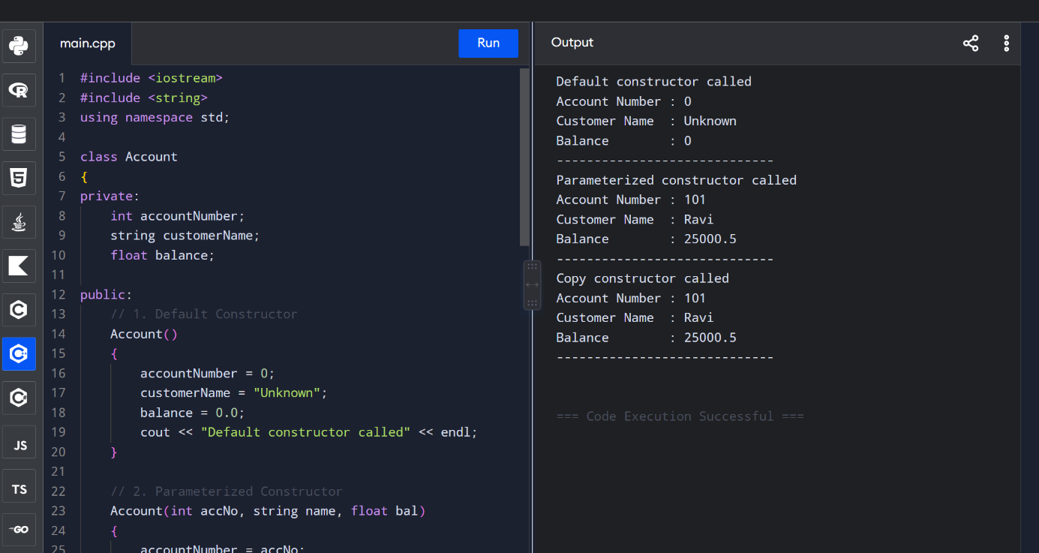

Question 2: Inventory Product Management System
A software company is developing an inventory management system using a class called Product. The system should allow products to be created, copied, combined, and removed from memory. Write a complete C++ program for the Inventory Product Management System using a parameterized constructor, copy constructor, destructor, and overloaded + operator. Demonstrate the complete object lifecycle through suitable output statements Analyze:
- Design the Product class with appropriate data members.
- Implement a parameterized constructor to initialize product details.
- Implement a copy constructor to duplicate a product.
- Implement a destructor to release resources when an object is destroyed.
- Overload the + operator to add the stock quantities of two products.
- Create two product objects using the parameterized constructor.
- Create another product using the copy constructor.
- Add two products using the overloaded + operator.
- Display the product details and resulting stock quantity.
- Trace and explain the sequence of constructor and destructor calls.
Code:
#include <iostream>
#include <string>
using namespace std;

class Product
{
private:
int productId;
string productName;
float price;
int stock;

public:
// 1. Parameterized Constructor
Product(int id, string name, float p, int s)
{
productId = id;
productName = name;
price = p;
stock = s;

cout << "Parameterized constructor called for "
<< productName << endl;
}

// 2. Copy Constructor
Product(const Product &P)
{
productId = P.productId;
productName = P.productName;
price = P.price;
stock = P.stock;

cout << "Copy constructor called for "
<< productName << endl;
}

// 3. Overloaded + Operator
Product operator+(const Product &P)
{
Product result(
0,
productName + " + " + P.productName,
price + P.price,
stock + P.stock
);

return result;
}

// Display product details
void display()
{
cout << "\nProduct ID : " << productId << endl;
cout << "Product Name : " << productName << endl;
cout << "Price : " << price << endl;
cout << "Stock : " << stock << endl;
}

// 4. Destructor
~Product()
{
cout << "Destructor called for "
<< productName << endl;
}
};

int main()
{
cout << "===== INVENTORY PRODUCT MANAGEMENT SYSTEM =====\n";

// Creating first product
cout << "\nCreating Product 1...\n";
Product P1(101, "Laptop", 50000, 10);

// Creating second product
cout << "\nCreating Product 2...\n";
Product P2(102, "Tablet", 25000, 20);

// Display products
cout << "\n===== PRODUCT DETAILS =====";
P1.display();
P2.display();

// Creating product using copy constructor
cout << "\nCreating Product 3 using Copy Constructor...\n";
Product P3(P1);

cout << "\n===== COPIED PRODUCT =====";
P3.display();

// Adding two products
cout << "\nAdding Product 1 and Product 2...\n";
Product P4 = P1 + P2;

cout << "\n===== RESULTING PRODUCT =====";
P4.display();

cout << "\n===== END OF MAIN =====\n";

return 0;
}

Output:
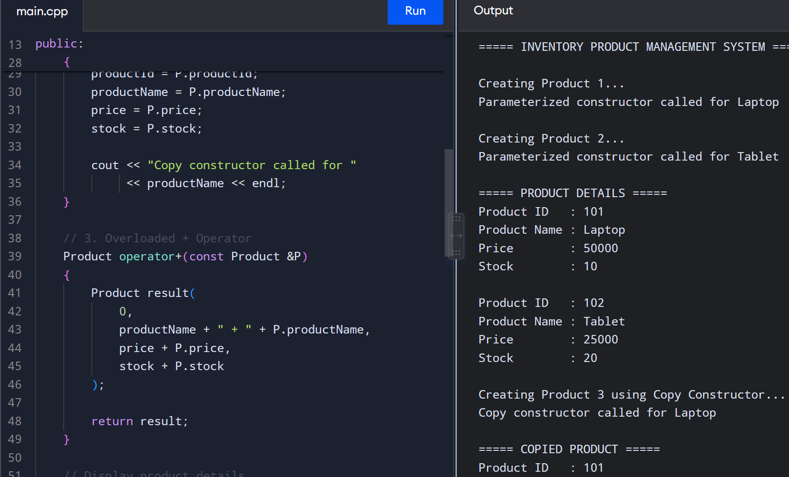

Question 3: Shopping Cart Management System
An online shopping application maintains customer shopping carts. A cart contains multiple products and their quantities. The system should support creating a cart, duplicating an existing cart, and merging two carts. Write a complete C++ program to implement the ShoppingCart system. Demonstrate parameterized construction, copy construction, cart merging using +, and destruction of objects.
Tasks:
- Design the Product class with appropriate data members.
- Implement a parameterized constructor to initialize product details.
- Implement a copy constructor to duplicate a product.
- Implement a destructor to release resources when an object is destroyed.
- Overload the + operator to add the stock quantities of two products.
- Create two product objects using the parameterized constructor.
- Create another product using the copy constructor.
- Add two products using the overloaded + operator.
- Display the product details and resulting stock quantity.
- Trace and explain the sequence of constructor and destructor calls.
- Explain what may happen if dynamically allocated memory is not released in the destructor

Code:
#include <iostream>
#include <string>
using namespace std;

class Product
{
private:
int productId;
string productName;
float price;
int quantity;

public:
// Parameterized constructor
Product(int id, string name, float p, int q)
{
productId = id;
productName = name;
price = p;
quantity = q;

cout << "Parameterized constructor called for "
<< productName << endl;
}

// Copy constructor
Product(const Product &P)
{
productId = P.productId;
productName = P.productName;
price = P.price;
quantity = P.quantity;

cout << "Copy constructor called for "
<< productName << endl;
}

// Overloaded + operator
Product operator+(const Product &P)
{
Product result(
productId,
productName,
price,
quantity + P.quantity
);

return result;
}

// Display product details
void display()
{
cout << "\nProduct ID : " << productId << endl;
cout << "Product Name : " << productName << endl;
cout << "Price : " << price << endl;
cout << "Quantity : " << quantity << endl;
}

// Destructor
~Product()
{
cout << "Destructor called for "
<< productName << endl;
}
};

int main()
{
cout << "===== SHOPPING CART SYSTEM =====\n";

// 1. Create first product
cout << "\nCreating Product 1...\n";
Product P1(101, "Laptop", 50000, 2);

// 2. Create second product
cout << "\nCreating Product 2...\n";
Product P2(102, "Mouse", 1000, 3);

// Display products
cout << "\n===== PRODUCT DETAILS =====";
P1.display();
P2.display();

// 3. Create product using copy constructor
cout << "\nCreating Product 3 using Copy Constructor...\n";
Product P3(P1);

cout << "\n===== COPIED PRODUCT =====";
P3.display();

// 4. Merge/add two products
cout << "\nAdding Product quantities...\n";
Product P4 = P1 + P1;

cout << "\n===== MERGED PRODUCT =====";
P4.display();

cout << "\n===== END OF PROGRAM =====\n";

return 0;
}

Output:

